Queries
1-3
- Print a list of all doctors at hospital id 3- NOTE this needs join
SELECT person_id FROM doctors WHERE hospital_id = 3;
- Print a list of all prescriptions for a specific patient, ordered by presc date
SELECT * FROM prescriptions WHERE patient_id = 621 ORDER BY prescription_date;
- Print list of all presc that doctor id 20 has written
SELECT * FROM prescriptions WHERE doctor_id = 20;

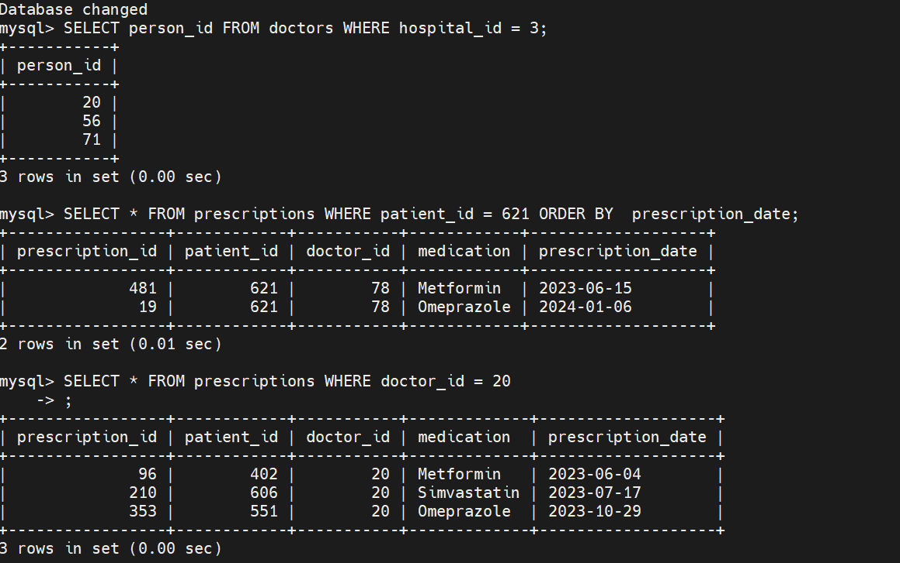
4.Add new pt :
INSERT INTO patients (name, date_of_birth, address, role, doctor_id) VALUES ('rachael dave', '1990-01-01', '1Darent Club,WA 10465', 'Patient', 20);
Check
SELECT * from patients WHERE person_id =701;

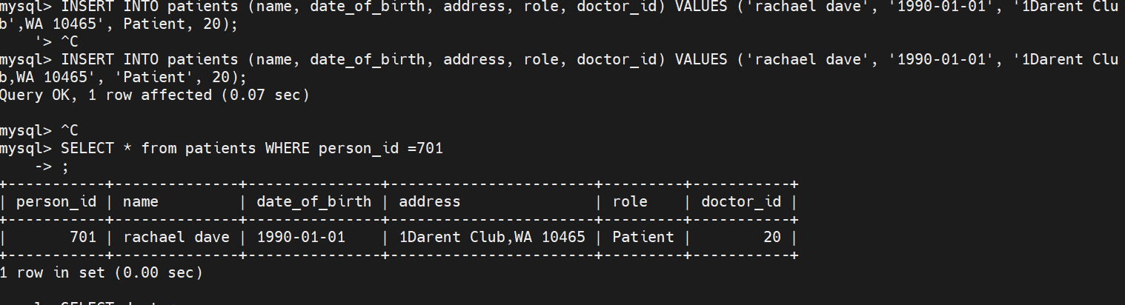

5. Select the dr who did the most presc
This needs to join doctors and prescriptions table
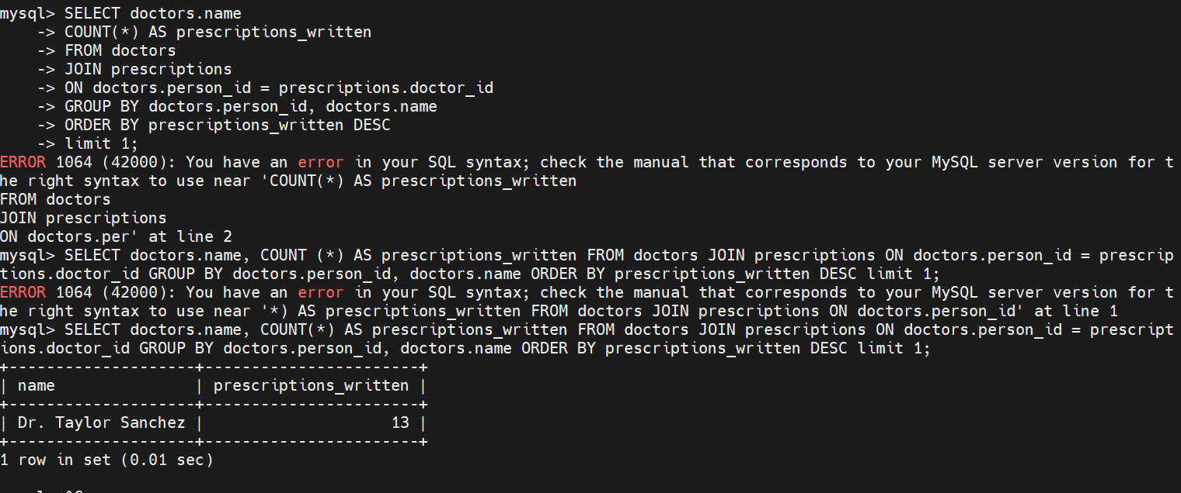
6. all drs at hosp with biggest size
Join drs and hosp using maximum size
